Assignment1:
Use schema in file housing_data_schema.pbix in order to generate the following Report and create needed measure then Create role that can see data related to ‘Austin’ City only and test it.

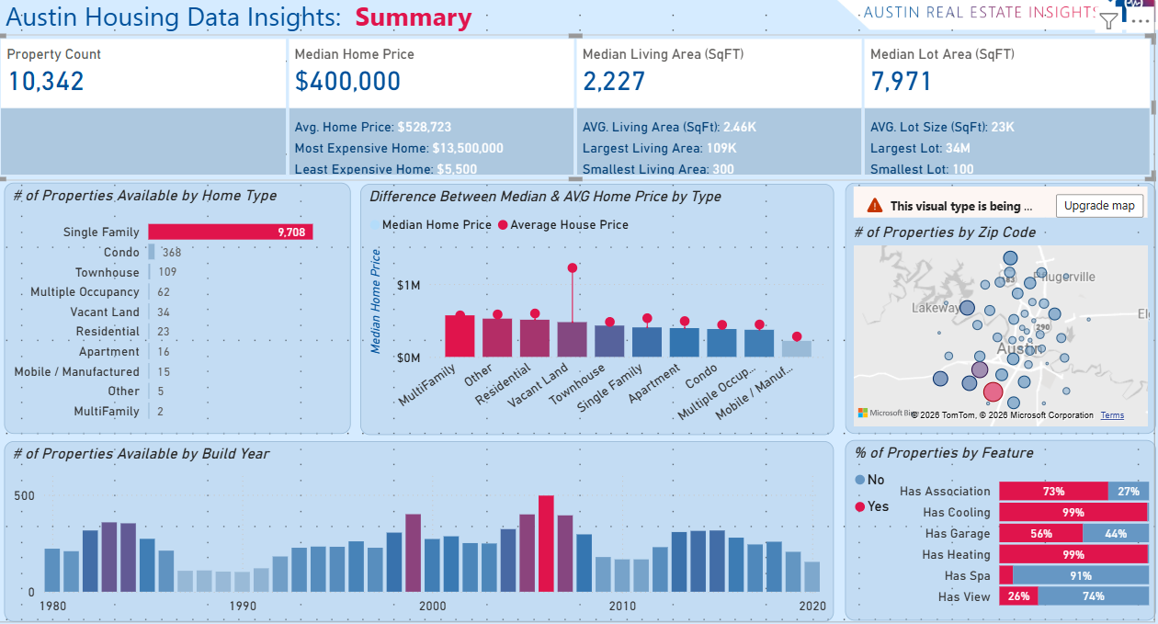

Assignment2:
Use Rankx dax function to display top 5 home type based on latest price
